**20 JavaScript Array Methods Every Developer Should Know -** [fatfish](https://fatfish.medium.com/?source=post_page-----6c04cc7a557d--------------------------------) Jun 30, 2022

Do you know how these 20 array methods are implemented?

**Preface**

My friends, you must be very familiar with arrays in JavaScript, we use its various methods every day, such as push, pop, forEach, map...etc.

**But is it enough just to use it?** So excellent you must not want to stop here. I want to challenge with you to realize the function of 20+ array methods.

**1. forEach**

forEach is a very frequently used array method in our work, and it is relatively simple to implement. It is the first function we need to get done.

**Code**

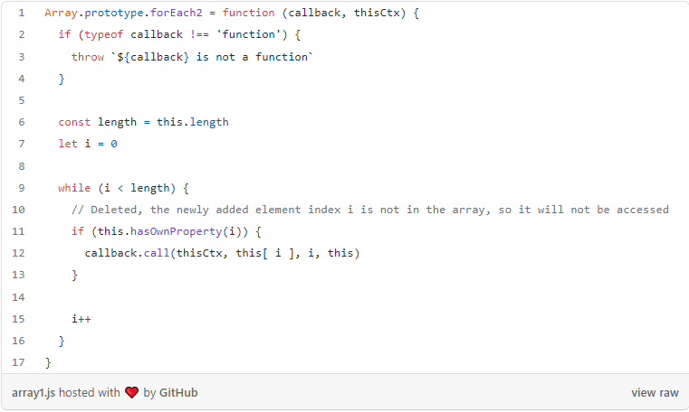

**Test it**

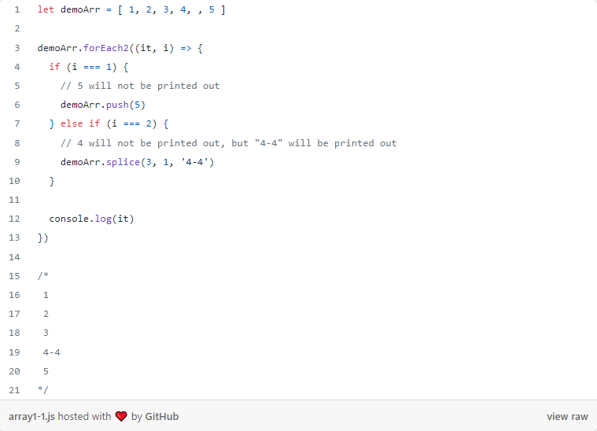

Wow, Congratulations! We have implemented the feature of forEach.

# 2. map

What do you generally use map for? Most of the time it is to convert one array into another array.

**Code**

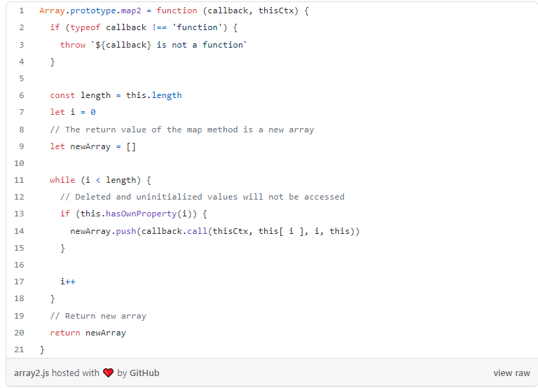

**Test it**

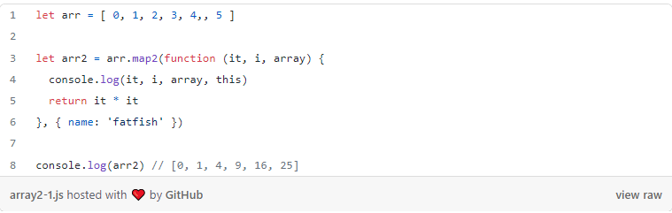

Friends, do you think it is not difficult? That's because you're so good.

# 3. every

(From [MDN](https://developer.mozilla.org/en-US/docs/Web/JavaScript/Reference/Global_Objects/Array/every)) The every() method tests whether all elements in the array pass the test implemented by the provided function. It returns a Boolean value.

The every method has three points that you may not have noticed before, what are they?

1. Calling the every method on an empty array will return true.
2. The callback method will only be called by an index that has already been assigned a value.
3. callback will not be called if the value is deleted

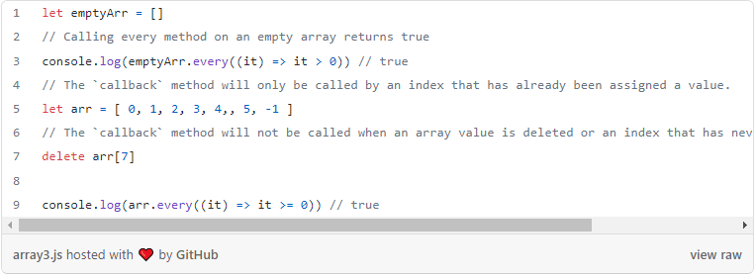

**Code**

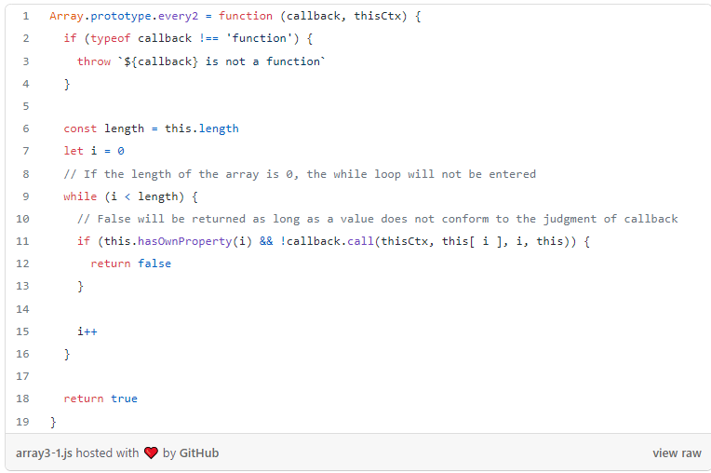

**Test it**

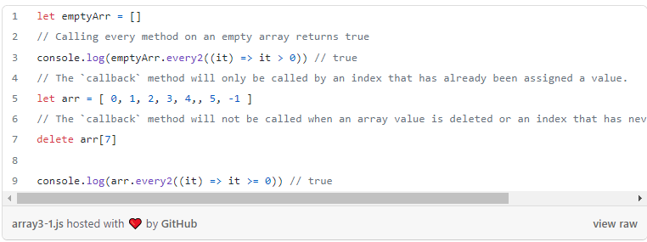

# 4. some

(from [MDN](https://developer.mozilla.org/en-US/docs/Web/JavaScript/Reference/Global_Objects/Array/some)) The some() method tests whether at least one element in the array passes the test implemented by the provided function.

**Code**

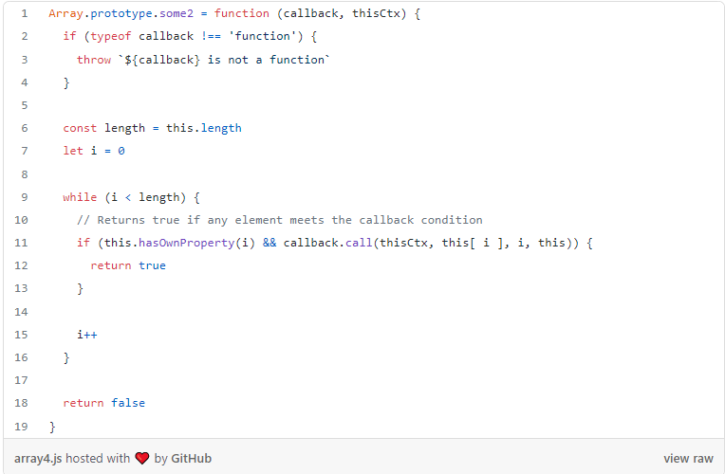

**Test it**

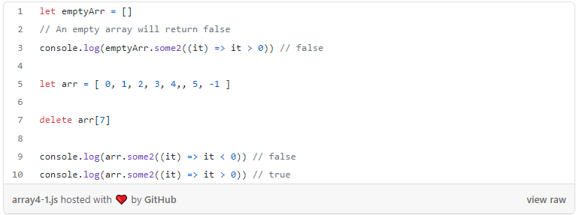

# 5. filter

(from [MDN](https://developer.mozilla.org/en-US/docs/Web/JavaScript/Reference/Global_Objects/Array/filter)) The filter() method creates a new array with all elements that pass the test implemented by the provided function.

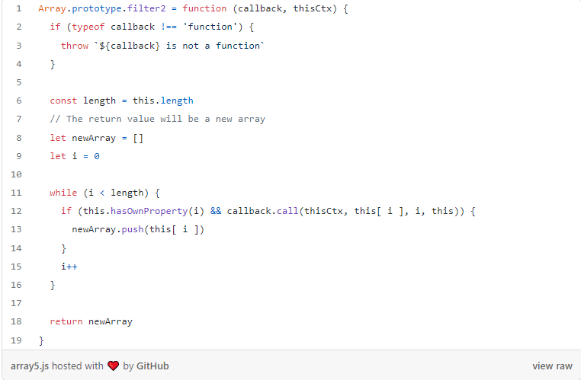

**Test it**

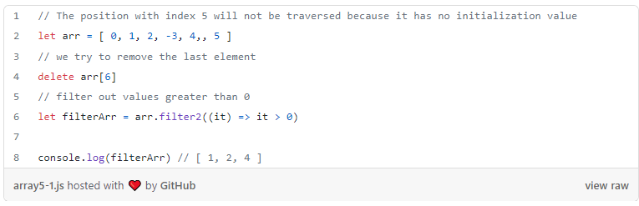

# 6. reduce

This function is a little more complicated. Let's use an example to see how it is used.

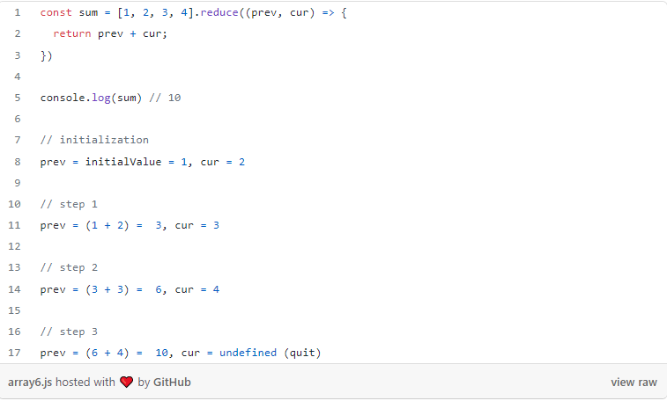

**Code**

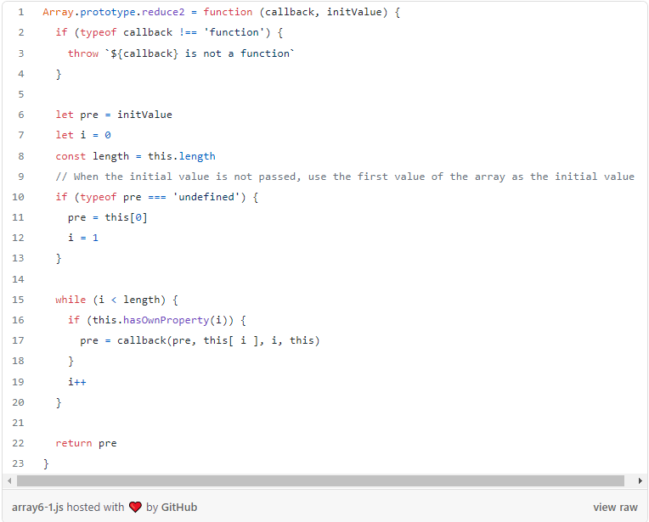

**Test it**

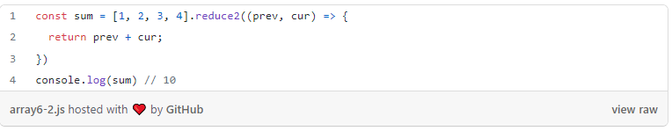

# 7. reduceRight

The reduceRight() method applies a function against an accumulator and each value of the array (from right to left) to reduce it to a single value.

It is very similar to reduce except that reduceRight traverses from right to left.

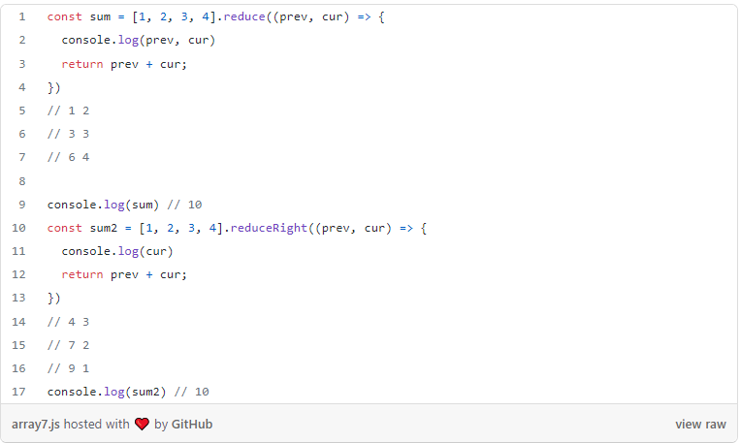

**Code**

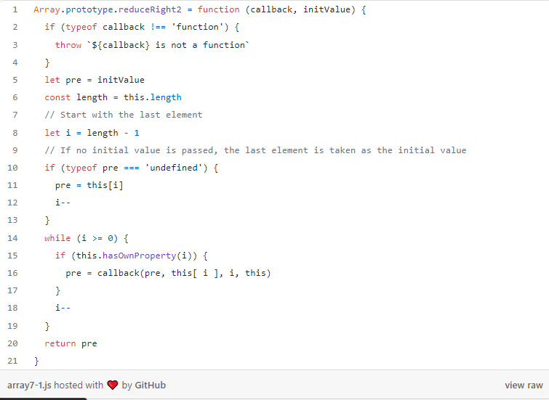

**Test it**

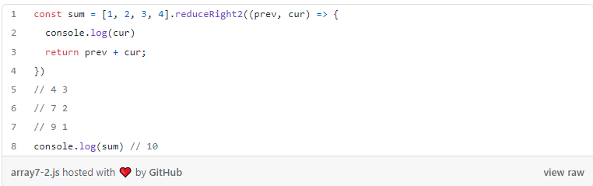

# 8. find

(From [MDN](https://developer.mozilla.org/en-US/docs/Web/JavaScript/Reference/Global_Objects/Array/find)) The find() method returns the first element in the provided array that satisfies the provided testing function. If no values satisfy the testing function, undefined is returned.

**Code**

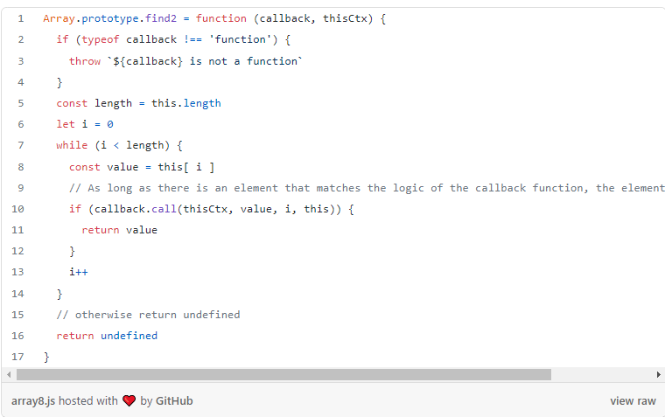

**Test it**

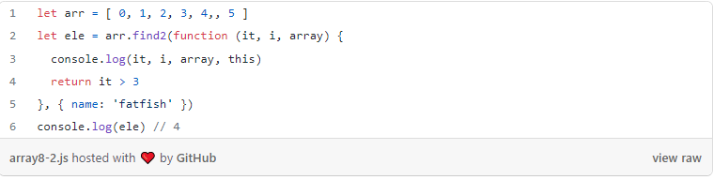

# 9. findIndex

(From [MDN](https://developer.mozilla.org/en-US/docs/Web/JavaScript/Reference/Global_Objects/Array/findIndex)) The findIndex() method returns the index of the first element in the array that satisfies the provided testing function. Otherwise, it returns -1, indicating that no element passed the test.

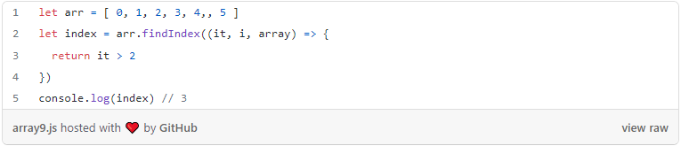

**Code** 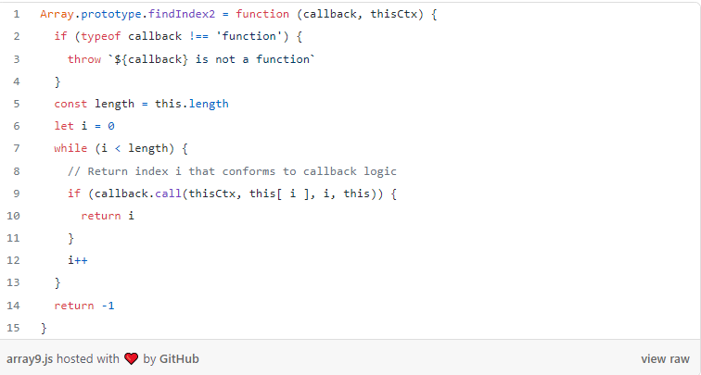

**Test it**

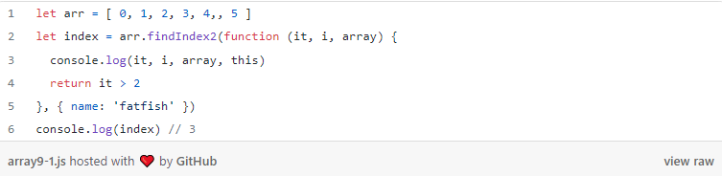

# 10. indexOf

(From [MDN](https://developer.mozilla.org/en-US/docs/Web/JavaScript/Reference/Global_Objects/Array/indexOf))The indexOf() method returns the first index at which a given element can be found in the array, or -1 if it is not present.



**Notes:**

1. If the index value at which the search starts is greater than or equal to the length of the array, it means that the search will not be performed in the array, and returns -1.
2. If fromIndex is a negative number, it will be searched according to the rule that -1 means to start searching from the last element, -2 means to start searching from the penultimate element, and so on.
3. If fromIndex is a negative number, the array is still searched from front to back.

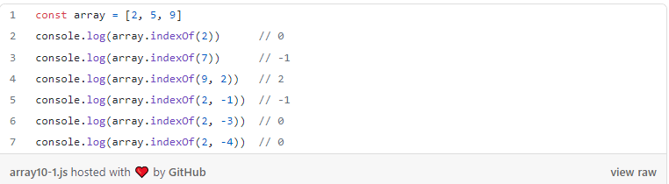

**Code**

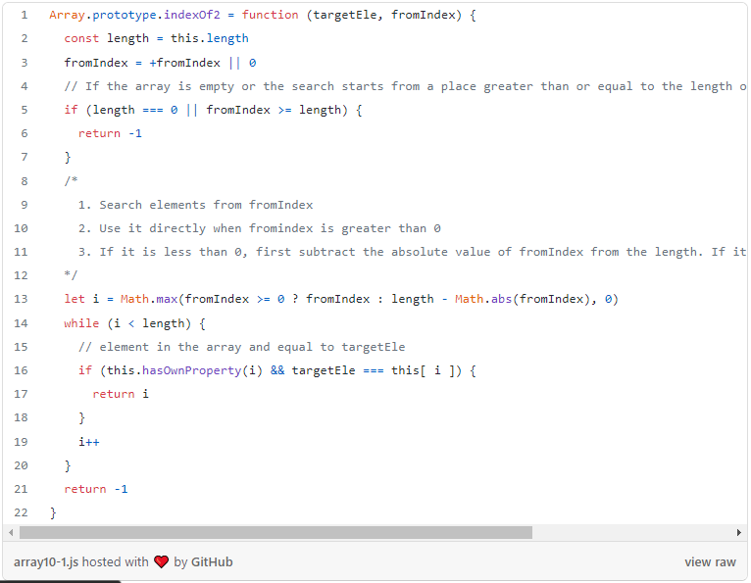

**Test it**

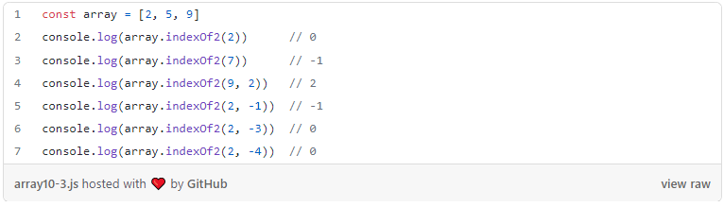

# 11. lastIndexOf

(From [MDN](https://developer.mozilla.org/en-US/docs/Web/JavaScript/Reference/Global_Objects/Array/lastIndexOf))The lastIndexOf() method returns the last index at which a given element can be found in the array, or -1 if it is not present. The array is searched backward, starting at fromIndex.

It is very similar to indexOf except for that lastIndexOf traverses from right to left.

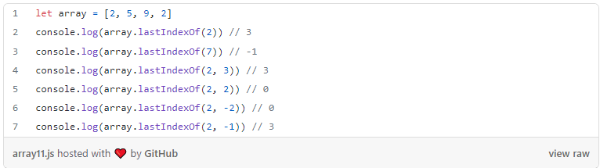

**Code**

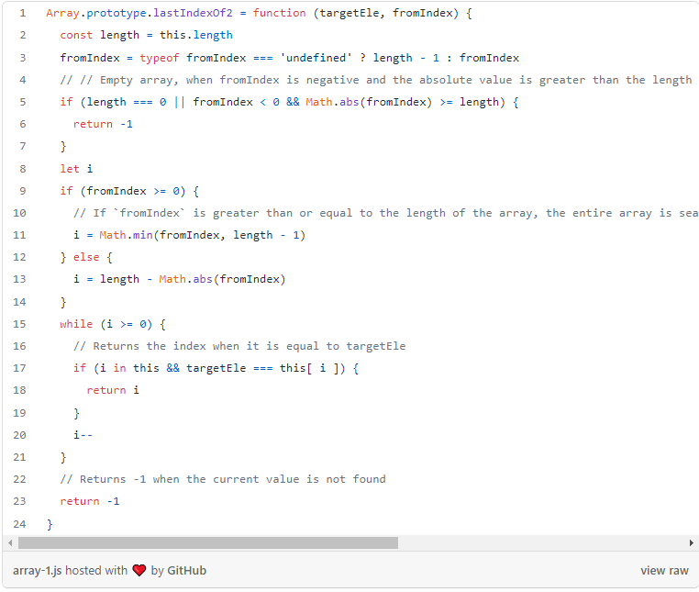

**Test it**

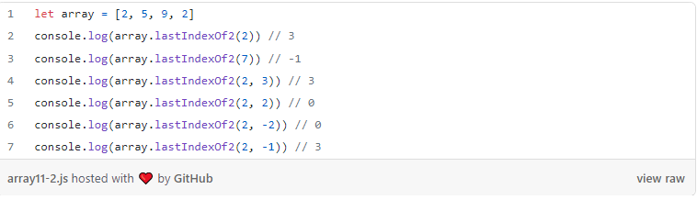

# 12. includes

(From [MDN](https://developer.mozilla.org/en-US/docs/Web/JavaScript/Reference/Global_Objects/Array/includes))The includes() method determines whether an array includes a certain value among its entries, returning true or false as appropriate.



**Notes**

1. The includes method will search valueToFind starting at the fromIndex index.
2. If fromIndex is negative, it starts to search the index of array.length + fromIndex.
3. If NaN exists in the array, [..., NaN] Includes (NaN) is true.

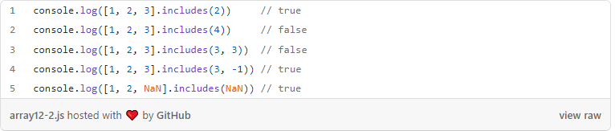

**Code**

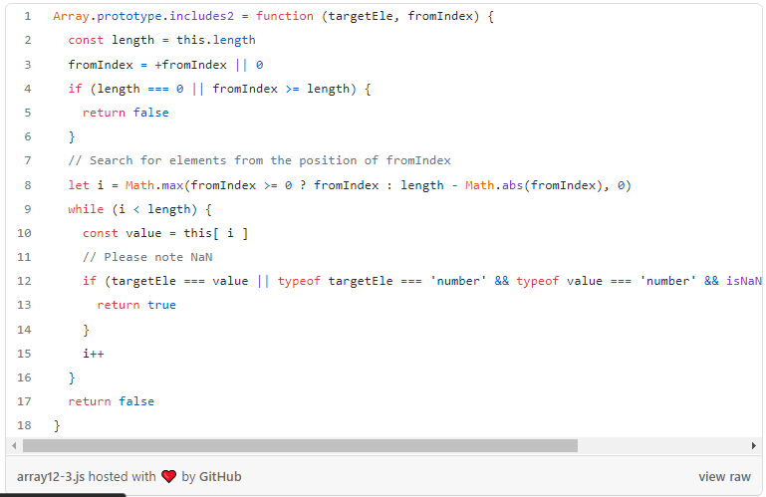

**Test it**

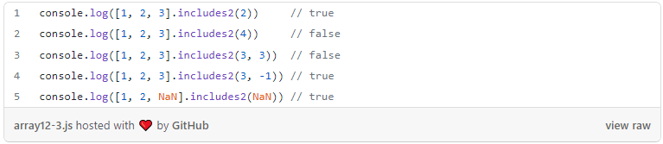

# 13. push

(From [MDN](https://developer.mozilla.org/en-US/docs/Web/JavaScript/Reference/Global_Objects/Array/push)) The push() method adds one or more elements to the end of an array and returns the new length of the array.

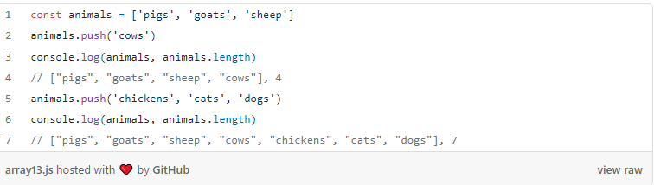

**Code**

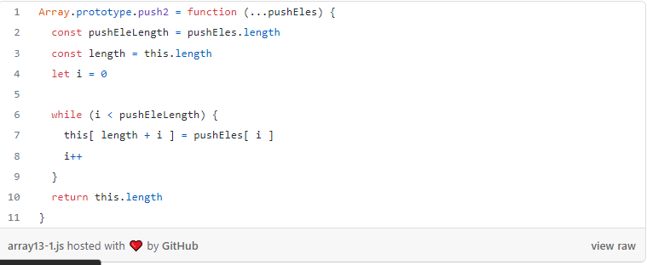

**Test it**

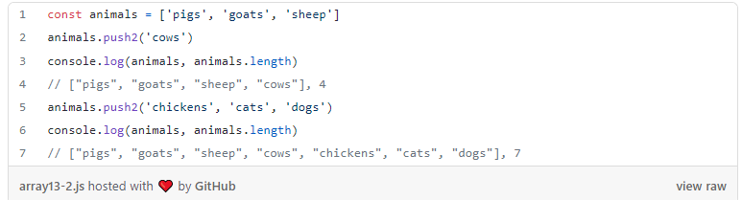

# 14. pop

(From [MDN](https://developer.mozilla.org/en-US/docs/Web/JavaScript/Reference/Global_Objects/Array/pop)) The pop() method removes the last element from an array and returns that element. This method changes the length of the array.

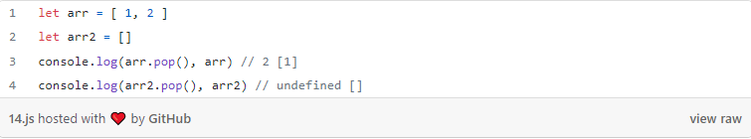

**Code**

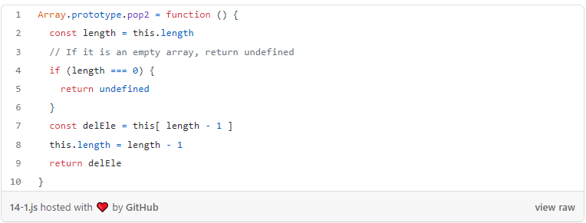

**Test it**

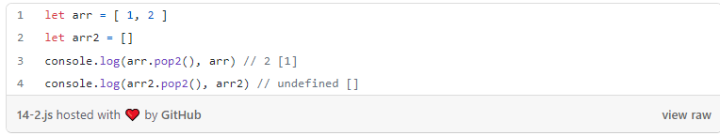

# 15. unshift

(From [MDN](https://developer.mozilla.org/en-US/docs/Web/JavaScript/Reference/Global_Objects/Array/unshift)) The unshift() method adds one or more elements to the beginning of an array and returns the new length of the array.

**Notes**

If you pass in multiple parameters to call unshift once, you will get different results than if you pass in a parameter to call unshift multiple times (for example, a circular call).

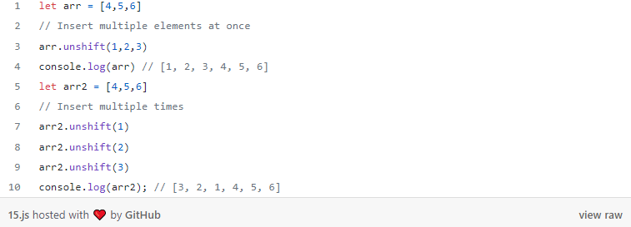

**Code**

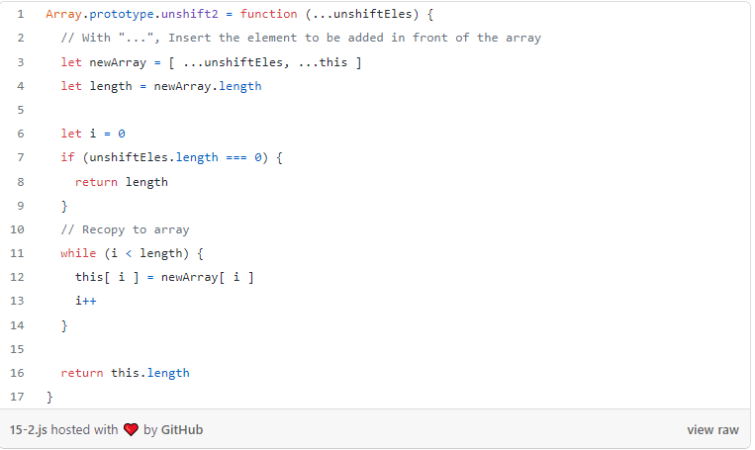

**Test it**

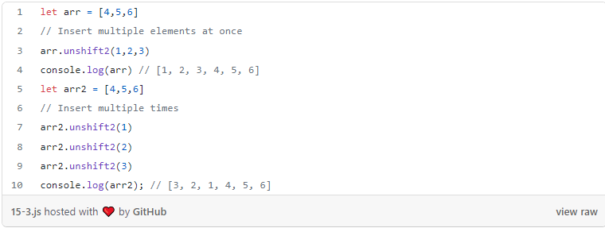

# 16. shift

(From [MDN](https://developer.mozilla.org/en-US/docs/Web/JavaScript/Reference/Global_Objects/Array/shift)) The shift() method removes the first element from an array and returns that removed element. This method changes the length of the array.

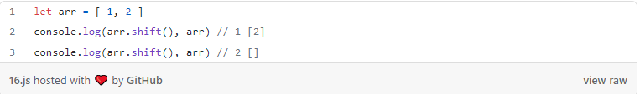

**Code**

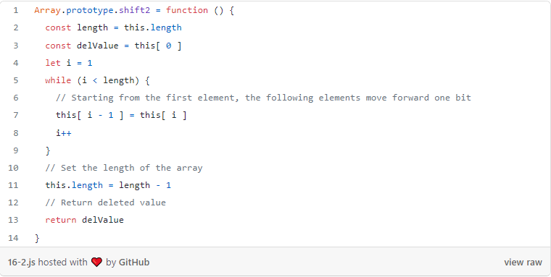

**Test it**

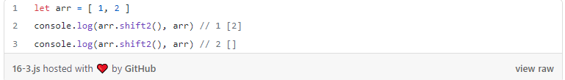

# 17. reverse

(From [MDN](https://developer.mozilla.org/en-US/docs/Web/JavaScript/Reference/Global_Objects/Array/reverse)) The reverse() method reverses an array in place. The first array element becomes the last, and the last array element becomes the first.

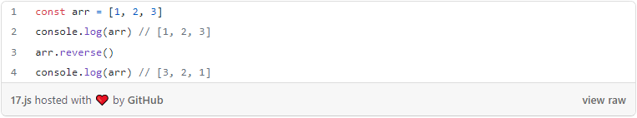

**Code**

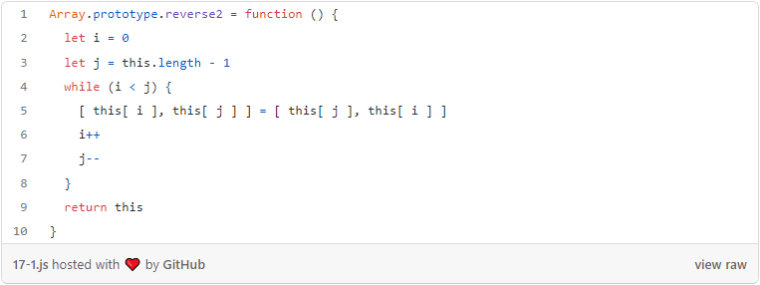

**Test**

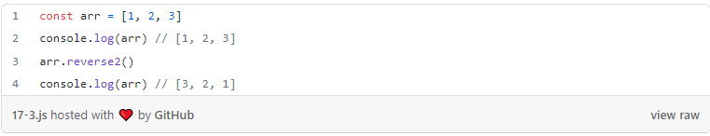

# 18. fill

(From [MDN](https://developer.mozilla.org/en-US/docs/Web/JavaScript/Reference/Global_Objects/Array/fill)) The fill() method changes all elements in an array to a static value, from a start index (default 0) to an end index (default array.length). It returns the modified array.

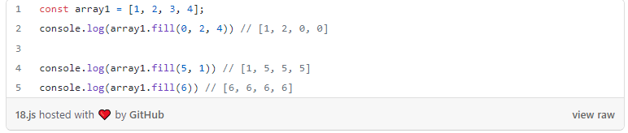

**Code**

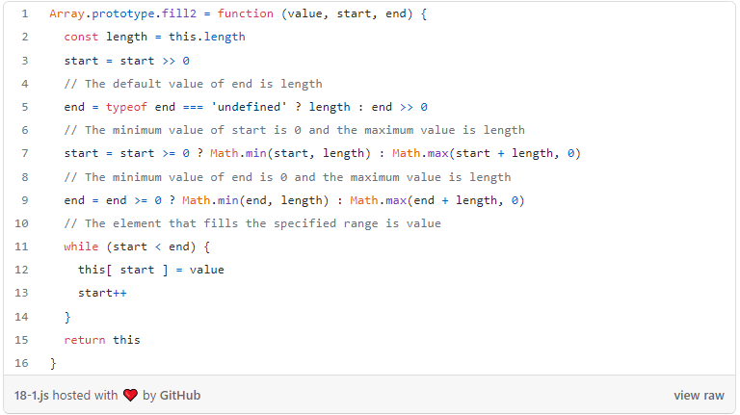

**Test it**

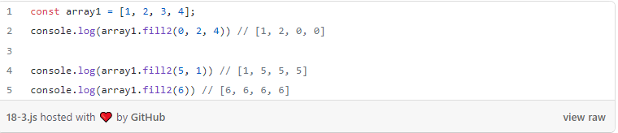

# 19. concat

(From [MDN](https://developer.mozilla.org/en-US/docs/Web/JavaScript/Reference/Global_Objects/Array/concat)) The concat() method is used to merge two or more arrays. This method does not change the existing arrays but instead returns a new array.

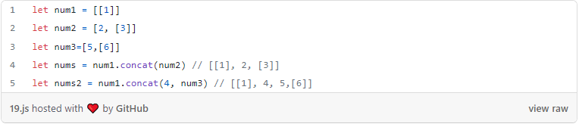

**Code**

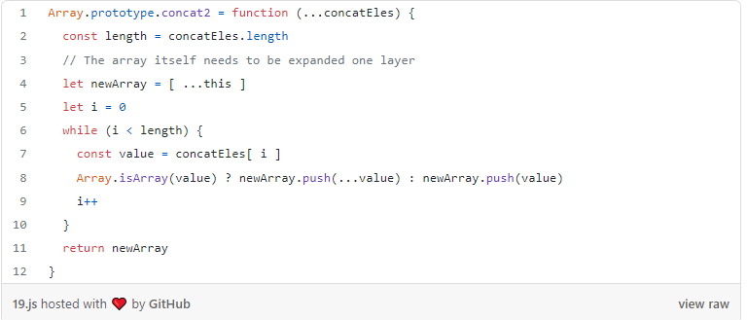

**Test it**

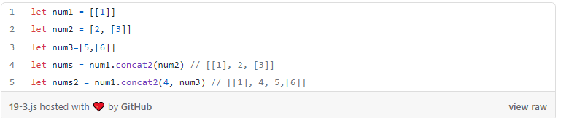

# 20. join

(From [MDN](https://developer.mozilla.org/en-US/docs/Web/JavaScript/Reference/Global_Objects/Array/join)) The join() method creates and returns a new string by concatenating all of the elements in an array (or an array-like object), separated by commas or a specified separator string. If the array has only one item, then that item will be returned without using the separator.

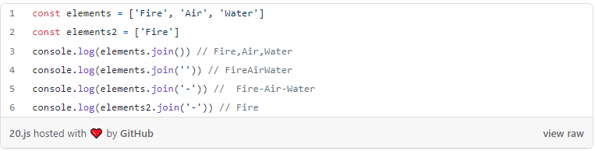

**Code**

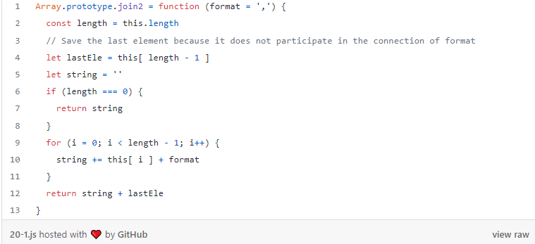

**Test it**

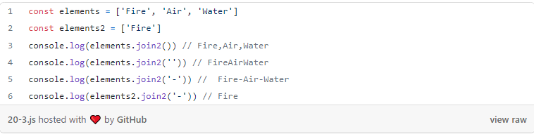

# Finally

**Thanks for reading.**